CANTEEN MANAGMENT



Problem Solving with Programming

**Computer Science & Engineering**

**By**

Roll.No : 2103A52121 Name: A.DRUVA KUMAR

Roll.No:2103A52137 Name: G.SRI HARSHINI

Roll.No:2103A52140 Name: K. ARCHANA

Roll.No: 2103A52118 Name: P. AASHISH

Roll.No: 2103A52146 Name: K. PAVAN RAJ

Roll.No: 2103A52172 Name: T. AXITH REDDY

**Under the Guidance of**

Dr.M.Sheshikala

Assoc.Prof

**Submitted to**



PSP-PROJECT

TOPIC- CANTEEN MANAGEMENT SYSTEM

H2 SECTION(BATCH-05)

|  |  |
| --- | --- |
| CONTENTS | Pg.no |
| 1. ABSTRACT 2. PROJECT REQUIRMENTS 3. PROJECT DOCUMENTATION 4. CODE 5. OUTPUTS | 4  5-6  7-8  9-21  21-24 |

**DEPARTMENT OF COMPUTER SCIENCE AND ARTIFICIAL INTELLIGENCE**

**CERTIFICATE**

This is to certify that the Course Project Report entitled “

” is a record of bonafide work carried out by the student(s) ----------------------------------------------------bearing Roll No(s) ------------------

_______________during the academic year 2021-22.

**Supervisor Head of the** Department

**External Examiner**

CANTEEN MANAGEMENT

SYSTEM

ABSTRACT:

**SR CANTEEN**

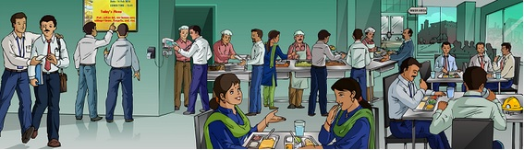

**This project is about “CANTEEN MANAGEMENT SYSTEM” The main objective of the Canteen Management System is to manage the details of Canteen, Sales, Orders, Items, Products. It manages all the information about Canteen, Food, Products, Canteen. The project is totally built at both employee and costumer end and thus both can access. The purpose of the project is to build an application program to reduce the manual work for managing the Canteen, Sales, Food, Orders. It tracks all the details about the Orders, Items, Products.**

To design and develop a web application for food ordering to be used by the canteen customers. ●The automated canteen ordering system can help in saving the time of the customers since they do not have to wait in queues to get the food. ●The interface will be user-friendly and easy to use by any user. ●The details of the orders placed by a customer got easily through the use of this application.

PROJECT REQUIREMENTS:

HARDWARE:

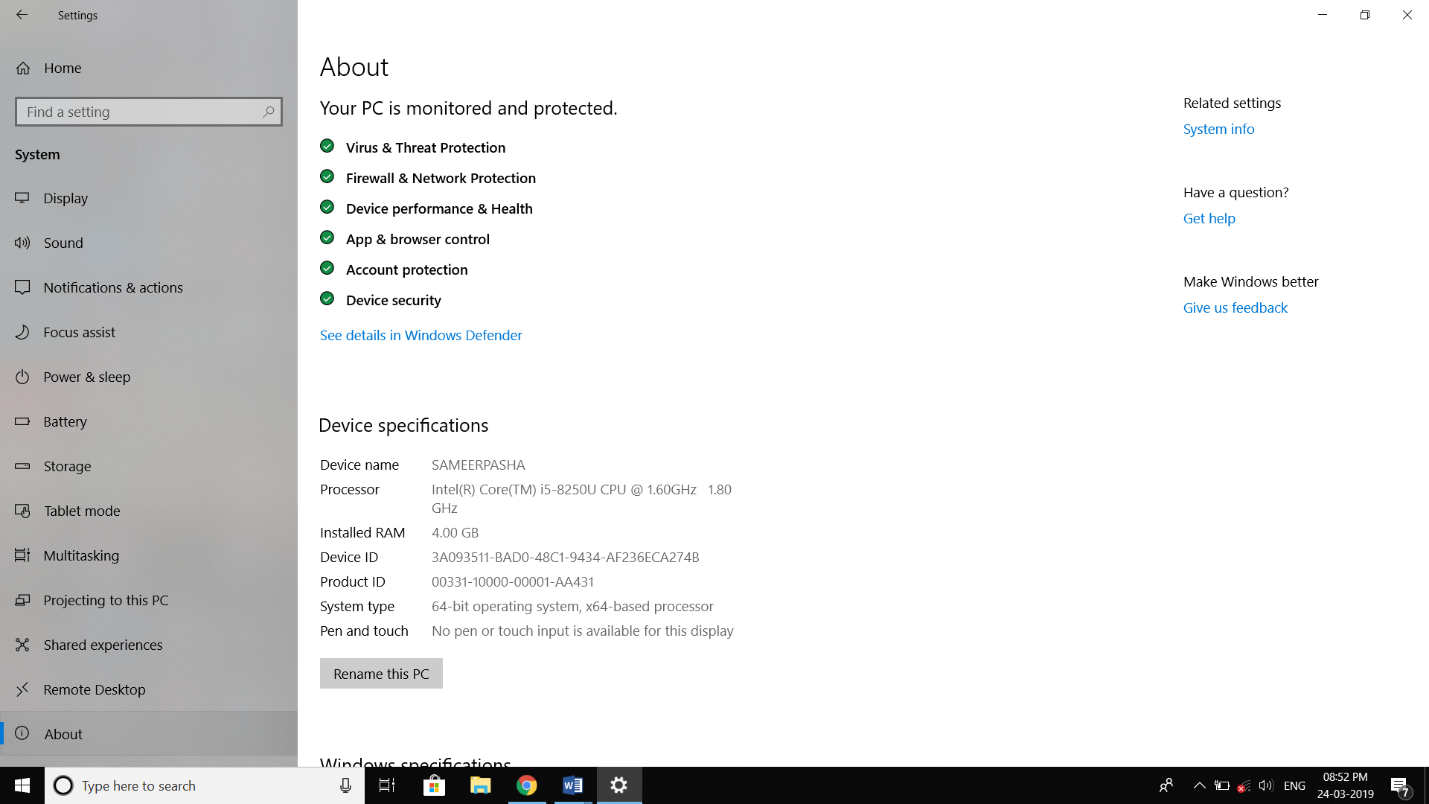

SOFTWARE: DEV c++

+

Dev-C++ is a free full-featured integrated development environment distributed under the GNU General Public License for programming in C and C++. It is written in Delphi. It is bundled with, and uses, the MinGW or TDM-GCC 64bit port of the GCC as its compiler.

[**Written in**](https://www.google.com/search?safe=active&rlz=1C1NDCM_enIN810IN811&q=dev-c%2B%2B+written+in&stick=H4sIAAAAAAAAAOPgE-LUz9U3MIrPSLfQUsoot9JPzs_JSU0uyczP0y_OTyspTyxKtSovyiwpSc1TyMxbxCqUklqmm6ytrYAQBAAN8MdcRgAAAA&sa=X&ved=2ahUKEwj4qKqaxZ3hAhWe7HMBHQBUCGEQ6BMoADAlegQICxAG)**:**[Object Pascal](https://www.google.com/search?safe=active&rlz=1C1NDCM_enIN810IN811&q=Object+Pascal&stick=H4sIAAAAAAAAAOPgE-LUz9U3MIrPSLdQgjArs9LjtZQyyq30k_NzclKTSzLz8_SL89NKyhOLUq3KizJLSlLzFDLzFrHy-idlAeUVAhKLkxNzAJ7Mls1MAAAA&sa=X&ved=2ahUKEwj4qKqaxZ3hAhWe7HMBHQBUCGEQmxMoATAlegQICxAH)

[**Developer(s)**](https://www.google.com/search?safe=active&rlz=1C1NDCM_enIN810IN811&q=dev-c%2B%2B+developers&sa=X&ved=2ahUKEwj4qKqaxZ3hAhWe7HMBHQBUCGEQ6BMoADAmegQICxAK)**:**Bloodshed Software until 2005, Orwell (Johan Mes) since 2011

[**License**](https://www.google.com/search?safe=active&rlz=1C1NDCM_enIN810IN811&q=dev-c%2B%2B+license&sa=X&ved=2ahUKEwj4qKqaxZ3hAhWe7HMBHQBUCGEQ6BMoADAnegQICxAN)**:**[GNU General Public License](https://www.google.com/search?safe=active&rlz=1C1NDCM_enIN810IN811&q=GNU+General+Public+License&stick=H4sIAAAAAAAAAONgVuLQz9U3MDZPzl3EKuXuF6rgnpqXWpSYoxBQmpSTmazgk5mcmlecCgBHUHbrKQAAAA&sa=X&ved=2ahUKEwj4qKqaxZ3hAhWe7HMBHQBUCGEQmxMoATAnegQICxAO)

[**Stable release**](https://www.google.com/search?safe=active&rlz=1C1NDCM_enIN810IN811&q=dev-c%2B%2B+stable+release&sa=X&ved=2ahUKEwj4qKqaxZ3hAhWe7HMBHQBUCGEQ6BMoADAoegQICxAR)**:**5.11 / [April 27, 2015](https://www.google.com/search?safe=active&rlz=1C1NDCM_enIN810IN811&q=April+27,+2015&stick=H4sIAAAAAAAAAONgVhLQL9E3MjExz6gwLC9PqUrJXsTK51hQlJmjYGSuo2BkYGgKALPTU2glAAAA&sa=X&ved=2ahUKEwj4qKqaxZ3hAhWe7HMBHQBUCGEQmxMoATAoegQICxAS); 3 years ago

[**Operating system**](https://www.google.com/search?safe=active&rlz=1C1NDCM_enIN810IN811&q=dev-c%2B%2B+operating+system&sa=X&ved=2ahUKEwj4qKqaxZ3hAhWe7HMBHQBUCGEQ6BMoADApegQICxAV)**:**[Microsoft Windows](https://www.google.com/search?safe=active&rlz=1C1NDCM_enIN810IN811&q=Microsoft+Windows&stick=H4sIAAAAAAAAAONgVuLQz9U3MCmKt1jEKuibmVyUX5yfVqIQnpmXkl9eDABrmtGqIAAAAA&sa=X&ved=2ahUKEwj4qKqaxZ3hAhWe7HMBHQBUCGEQmxMoATApegQICxAW), [Linux](https://www.google.com/search?safe=active&rlz=1C1NDCM_enIN810IN811&q=Linux&stick=H4sIAAAAAAAAAONgVuLUz9U3SCuoqipYxMrqk5lXWgEATgerNhUAAAA&sa=X&ved=2ahUKEwj4qKqaxZ3hAhWe7HMBHQBUCGEQmxMoAjApegQICxAX) (alpha only)

Project Documentation:

In this code we have used functions,structures and files:

FUNCTIONS:

There several advantages of using functions in our code

.It enhances the readability of a program.

.Using functions in our code made easy to understand

.It reduces the complexity of a program and gives it a modular structure.

By implementing functions and procedures in this program the programmer reduces coding time and debugging time thereby reducing the overall development time.

1.Employee function() is used enter the new items in to the stock and also can view previous bill.

Enter username

Enter password

New item in the stock

Previous bill

Select food type

Item name

Item number

Item price

No of plates

2.Customer function() is used order the food items that which was given by using employee function.

It contains details like

. Food type.

. No of plates.

.Bill.

3.Login function () is used to login for the employee to enter new items into the stock and also to view previous bills and username ,password provided for privacy purpose.

4.Bill function () is used to bill the food items in customers function ordered by customers based on food type and no of plates.

FILES:

If we want to enter a large amount of data normally, it takes a lot of time to enter them all. If we have a file containing all the data, we can easily access the contents of the file by using few commands in C. we can easily move our data from one computer to another without changes.

Structures:

It combines datatypes of different kinds.

Structures are used to represent a record

SR CANTEEN

Code:

#include<stdio.h>

int totalcost[100];

void employee();

void customer();

float bill(int );

void login();

void previousrec();

int k,o,n,i;

int count=0,i=0;

struct canteen

{

int id;

char item[50];

int price;

int nop;

}s;

main()

{

printf("\n\n\t====================================\n");

printf("\t -WELCOME TO CANTEEN MANAGEMENT SYSTEM-\n");

printf("\t====================================");

int w,pwd,i,d,l;

printf("\n\n\t1.EMPLOYEE\n\n\t2.CUSTOMER");

printf("\n\n\tSELECT YOUR CHOICE : ");

scanf("%d",&w);

if(w==1)

{

employee();

}

else

{

customer();

}

}

void employee()

{

int l;

FILE *fp1;

FILE *fp2;

FILE *fp3;

FILE *fp4;

int z,n,r;

login();

do

{

printf("\n\n\t=========================================================\n");

printf("\t -ADDING ITEMS TO THE STOCK AND VEIWING PREVIOUS BILLS-\n");

printf("\t==============================================================");

printf("\n\n\t1.TO ENTER NEW ITEMS IN THE STOCK\n\n\t2.VIEW PREVIOUS BILLS");

scanf("%d",&l);

switch(l)

{

printf("\n\n\t====================================\n");

printf("\t -ADDING ITEMS TO THE STOCK-\n");

printf("\t====================================");

do

{

case 1:

printf("\n\n\t1.ENTER TIFFINS\n\n\t2.ENTER MEALS\n\n\t3.ENTER SNACKS\n\n\t4.ENTER DRINKS");

scanf("%d",&z);

switch(z)

{

case 1:

fp1=fopen("C:/Users/DRUVA KUMAR/Desktop/dntiffins.txt","a");

do{

printf("\n\n\tENTER ITEM NUMBER : ");

fscanf(stdin,"%d",&s.id);

fprintf(fp1,"\n%d",s.id);

printf("\n\tENTER ITEM NAME : ");

fscanf(stdin,"%s",s.item);

fprintf(fp1," %s",s.item);

printf("\n\tENTER ITEM PRICE : ");

fscanf(stdin,"%d",&s.price);

fprintf(fp1," %d",s.price);

printf("\n\tENTER NUMBER OF PLATES : ");

fscanf(stdin,"%d",&s.nop);

fprintf(fp1," %d",s.nop);

printf("\n\tenter 22 to enter new tiffin item : ");

scanf("%d",&k);

}

while(k==22);

fclose(fp1);

break;

case 2:

fp2=fopen("C:/Users/DRUVA KUMAR/Desktop/dnmeals.txt","a");

do{

printf("\n\n\tENTER ITEM NUMBER : ");

fscanf(stdin,"%d",&s.id);

fprintf(fp2,"\n%d",s.id);

printf("\n\tENTER ITEM NAME : ");

fscanf(stdin,"%s",s.item);

fprintf(fp2," %s",s.item);

printf("\n\tENTER ITEM PRICE : ");

fscanf(stdin,"%d",&s.price);

fprintf(fp2," %d",s.price);

printf("\n\tENTER NUMBER OF PLATES :");

fscanf(stdin,"%d",&s.nop);

fprintf(fp2," %d",s.nop);

printf("\n\tenter 22 to enter new meals item : ");

scanf("%d",&k);

}

while(k==22);

fclose(fp2);

break;

case 3:

fp3=fopen("C:/Users/DRUVA KUMAR/Desktop/dnsnacks.txt","a");

do{

printf("\n\n\tENTER ITEM NUMBER : ");

fscanf(stdin,"%d",&s.id);

fprintf(fp3,"\n%d",s.id);

printf("\n\tENTER ITEM NAME : ");

fscanf(stdin,"%s",s.item);

fprintf(fp3," %s",s.item);

printf("\n\tENTER ITEM PRICE : ");

fscanf(stdin,"%d",&s.price);

fprintf(fp3," %d",s.price);

printf("\n\tENTER NUMBER OF PLATES ");

fscanf(stdin,"%d",&s.nop);

fprintf(fp3," %d",s.nop);

printf("\n\tenter 22 to enter new snack item : ");

scanf("%d",&k);

}

while(k==22);

fclose(fp3);

break;

case 4:

fp4=fopen("C:/Users/DRUVA KUMAR/Desktop/dndrinks.txt","a");

do{

printf("\n\n\tENTER ITEM NUMBER : ");

fscanf(stdin,"%d",&s.id);

fprintf(fp4,"\n%d",s.id);

printf("\n\tENTER ITEM NAME : ");

fscanf(stdin,"%s",s.item);

fprintf(fp4," %s",s.item);

printf("\n\tENTER ITEM PRICE :");

fscanf(stdin,"%d",&s.price);

fprintf(fp4," %d",s.price);

printf("\n\tENTER NUMBER OF DRINKS:");

fscanf(stdin,"%d",&s.nop);

fprintf(fp4," %d",s.nop);

printf("\n\tenter 22 to enter new tiffn item : ");

scanf("%d",&k);

}

while(k==22);

fclose(fp4);

break;

}

printf("\n\n\tENTER 1 TO ENTER NEW ITEM : ");

scanf("%d",&r);

}

while(r==1);

break;

case 2:

previousrec();

break;

}

printf("\n\n\tENTER 1 TO GO TO EMPLOYES MENU : ");

scanf("%d",&r);

}

while(r==1);

}

void customer()

{

FILE *fp1;

FILE *fp2;

FILE *fp3;

FILE *fp4;

FILE *fp5;

int z,n,r,d;

printf("\t--------------- SELECT YOUR MAIN MENU TYPE ------------------");

printf("\n\n\t1.TIFFINS\n\n\t2.MEALS\n\n\t3.SNACKS\n\n\t4.DRINKS");

printf("\n\n\tSELECT YOUR MENU TYPE : ");

scanf("%d",&z);

switch(z)

{

case 1:

fp1=fopen("C:/Users/DRUVA KUMAR/Desktop/dntiffins.txt","r");

printf("\n\n\t====================================\n");

printf("\t -TIFFIN MENU-\n");

printf("\t====================================");

printf("\nITEM NO.\tITEM NAME\tITEMPRICE \tNO.OFPLATES");

while(fscanf(fp1,"\n%d %s %d %d",&s.id,s.item,&s.price,&s.nop)!=EOF)

{

fprintf(stdout,"\n%d\t %s\t\t\t%d\t\t%d",s.id,s.item,s.price,s.nop);

}

printf("\nENTER ITEMNUMBER");

scanf("%d",&n);

fp1=fopen("C:/Users/DRUVA KUMAR/Desktop/dntiffins.txt","r");

while(fscanf(fp1,"\n%d %s %d %d",&s.id,s.item,&s.price,&s.nop)!=EOF)

{

if(n==s.id)

{

printf("\n\n\tyou have selected");

fprintf(stdout," %s",s.item);

printf("\n\n\tenter number of plates : ");

scanf("%d",&d);

fp5=fopen("C:/Users/DRUVA KUMAR/Desktop/dnrecords.txt","a");

fprintf(fp5,"\n%d %s %d %d",s.id,s.item,s.price,d);

fclose(fp5);

totalcost[i++]=d*s.price;

count++;

bill(count);

break;

}

}

fclose(fp1);

break;

case 2:

fp2=fopen("C:/Users/DRUVA KUMAR/Desktop/dnmeals.txt","r");

printf("\n\n\t====================================\n");

printf("\t -MEALS MENU-\n");

printf("\t====================================");

printf("\nITEM NO.\tITEM NAME\tITEMPRICE \tNO.OFPLATES");

while(fscanf(fp2,"\n%d %s %d %d",&s.id,s.item,&s.price,&s.nop)!=EOF)

{

fprintf(stdout,"\n%d\t %s\t\t\t%d\t\t%d",s.id,s.item,s.price,s.nop);

}

printf("\n\n\tENTER ITEMNUMBER : ");

scanf("%d",&n);

fp2=fopen("C:/Users/DRUVA KUMAR/Desktop/dnmeals.txt","r");

while(fscanf(fp2,"\n%d %s %d %d",&s.id,s.item,&s.price,&s.nop)!=EOF)

{

if(n==s.id)

{

printf("\n\n\tyou have selected");

fprintf(stdout," %s",s.item);

printf("\n\n\tenter number of plates : ");

scanf("%d",&d);

fp5=fopen("C:/Users/DRUVA KUMAR/Desktop/dnrecords.txt","a");

fprintf(fp5,"\n%d %s %d %d",s.id,s.item,s.price,d);

fclose(fp5);

totalcost[i++]=d*s.price;

count++;

bill(count);

break;

}

}

fclose(fp2);

break;

case 3:

fp3=fopen("C:/Users/DRUVAKUMAR/Desktop/dnsnacks.txt","r");

printf("\n\n\t====================================\n");

printf("\t -SNACKS MENU-\n");

printf("\t====================================");

printf("\nITEM NO.\tITEM NAME\tITEMPRICE \tNO.OFPLATES");

while(fscanf(fp3,"\n%d %s %d %d",&s.id,s.item,&s.price,&s.nop)!=EOF)

{

fprintf(stdout,"\n%d\t %s\t\t\t%d\t\t%d",s.id,s.item,s.price,s.nop);

}

printf("\n\n\tENTER ITEMNUMBER : ");

scanf("%d",&n);

fp3=fopen("C:/Users/DRUVA KUMAR/Desktop/dnsnacks.txt","r");

while(fscanf(fp3,"\n%d %s %d %d",&s.id,s.item,&s.price,&s.nop)!=EOF)

{

if(n==s.id)

{

printf("\n\n\tyou have selected");

fprintf(stdout," %s",s.item);

printf("\n\n\tenter number of plates : ");

scanf("%d",&d);

fp5=fopen("C:/Users/DRUVA KUMAR/Desktop/dnrecords.txt","a");

fprintf(fp5,"\n%d %s %d %d",s.id,s.item,s.price,d);

fclose(fp5);

totalcost[i++]=d*s.price;

count++;

bill(count);

break;

}

}

fclose(fp3);

break;

case 4:

fp4=fopen("C:/Users/DRUVA KUMAR/Desktop/dndrinks.txt","r");

printf("\n\n\t====================================\n");

printf("\t -DRINKS MENU-\n");

printf("\t====================================");

printf("\nITEM NO.\tITEM NAME\tITEMPRICE \tNO.OFPLATES");

while(fscanf(fp4,"\n%d %s %d %d",&s.id,s.item,&s.price,&s.nop)!=EOF)

{

fprintf(stdout,"\n%d\t %s\t\t\t%d\t\t%d",s.id,s.item,s.price,s.nop);

}

printf("\n\n\tENTER ITEMNUMBER : ");

scanf("%d",&n);

fp4=fopen("C:/Users/DRUVA KUMAR/Desktop/dndrinks.txt","r");

while(fscanf(fp4,"\n%d %s %d %d",&s.id,s.item,&s.price,&s.nop)!=EOF)

{

if(n==s.id)

{

printf("\n\n\tyou have selected");

fprintf(stdout," %s",s.item);

printf("\n\n\tenter number of Drinks : ");

scanf("%d",&d);

fp5=fopen("C:/Users/DRUVA KUMAR/Desktop/dnrecords.txt","a");

fprintf(fp5,"\n%d %s %d %d",s.id,s.item,s.price,d);

fclose(fp5);

totalcost[i++]=d*s.price;

count++;

bill(count);

break;

}

}

fclose(fp4);

break;

}

}

float bill(int count)

{

printf("%d",count);

int i,z=0,k;

float totalbill,gst;

printf("\n\n\tENTER 1 TO ORDER MORE : ");

scanf("%d",&k);

if(k==1)

{

customer();

}

else

{

for(i=0;i<count;i++)

{

printf("\n\n Bill amount for (order%d) = %d",i+1,totalcost[i]);

totalbill+=totalcost[i];

}

printf("\n\n Bill amount for all ordered food items =%f",totalbill);

printf("\n\n GST [14 percent] =%f",gst=totalbill*0.14);

printf("\n\n Total bill[including GST] =%f",totalbill=totalbill+gst);

}

}

void login()

{

int a,i;

char uname[10],pword[10];

char user[100]="druva";

char pass[10]="dn";

printf("\n\n\t====================LOGIN FORM====================\n");

A:

printf("\n\t\t\tENTER USERNAME:-");

scanf("%s",uname);

a=strcmp(uname,user);

if(a==0)

{

B:

printf("\n\t\t\tENTER PASSWORD:-");

scanf("%s",&pword);

}

else

{

printf("\n\t\t\tINVALID USERNAME");

printf("\n\n\t\t\tRE-ENTER AGAIN\n");

goto A;

}

i=strcmp(pass,pword);

if(i==0)

{

printf(" \n\n\n WELCOME TO CANTEEN MANAGEMENT SYSTEM !! YOUR LOGIN IS SUCCESSFUL");

printf("\n\n\t\tPRESS ENTER TO CONTINUE");

getch();

}

else

{

printf("\n\t\t\tWRONG PASSWORD..........");

printf("\n\n\t\t\tRE-ENTER PASSWORD\n");

goto B;

}

}

void previousrec()

{

FILE *fp5;

fp5=fopen("C:/Users/DRUVA KUMAR/Desktop/dnrecords.txt","r");

printf("--------------------------------PREVIOUSBILLS-------------------------------------");

printf("\nITEM NO.\tITEM NAME\tITEMPRICE\tNUMBER OF PLATES");

while(fscanf(fp5,"\n%d %s %d %d",&s.id,s.item,&s.price,&s.nop)!=EOF)

{

fprintf(stdout,"\n%d\t %s\t\t\t%d\t\t%d",s.id,s.item,s.price,s.nop);

}

}

OUTPUTs:

Entering the details:

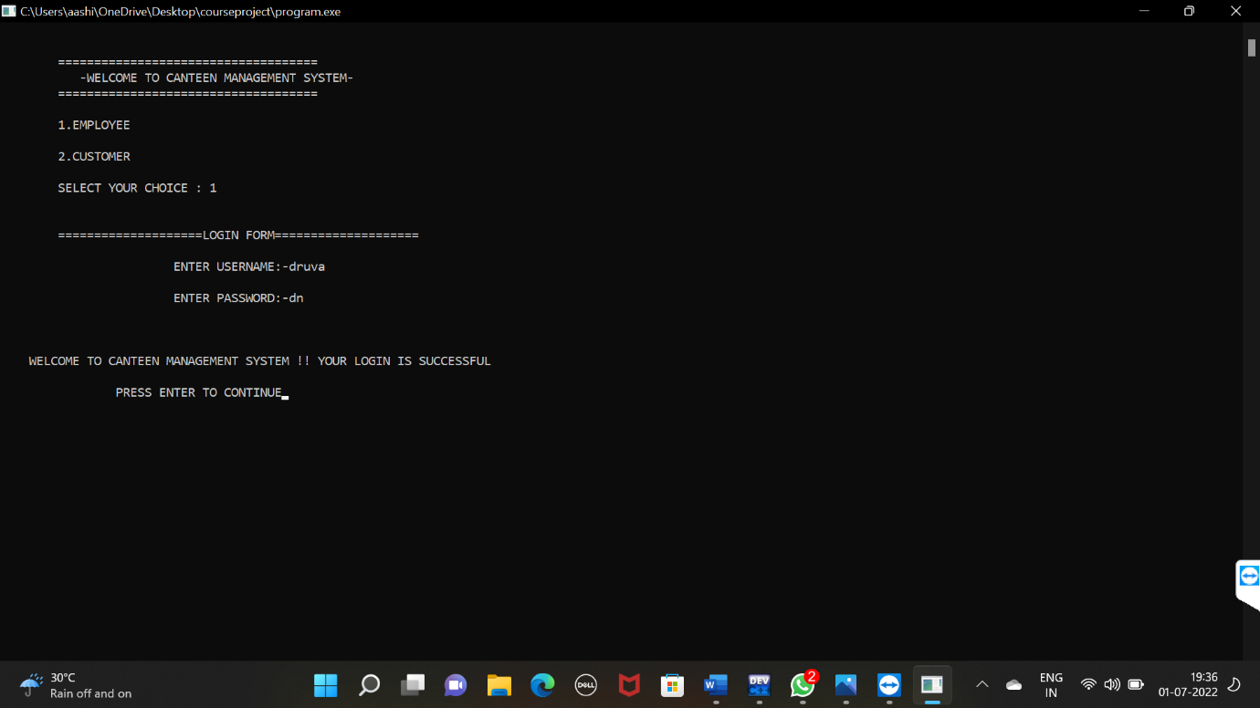

Entering items in stock:

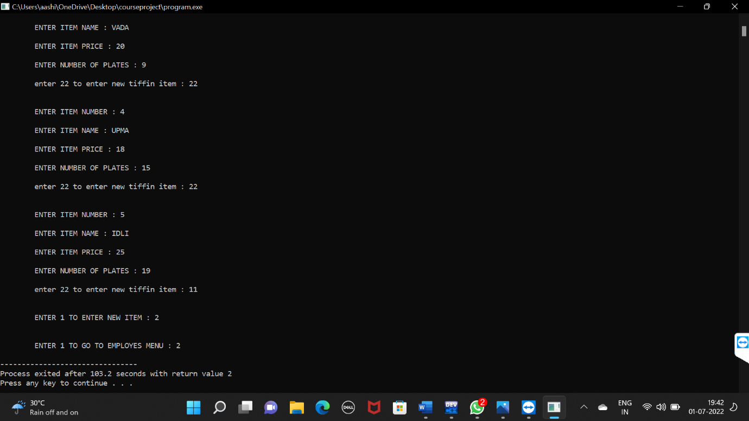

Ordering items through costumer function:

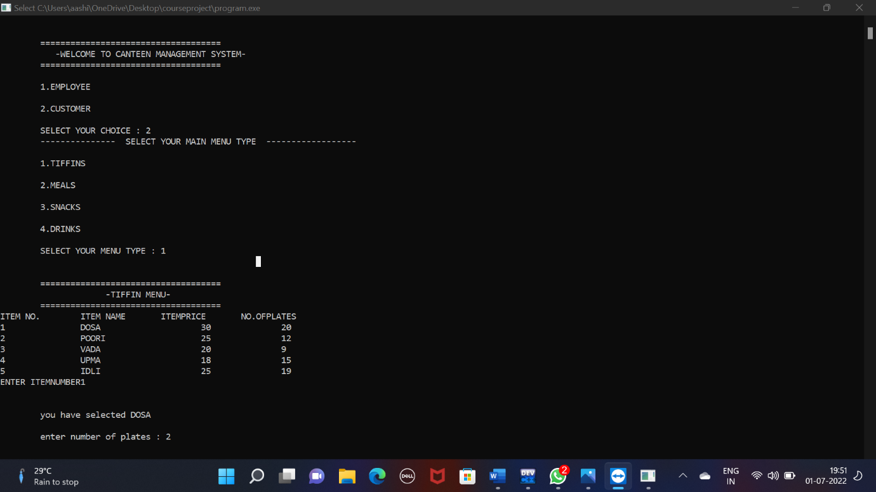

Records of previous bills:

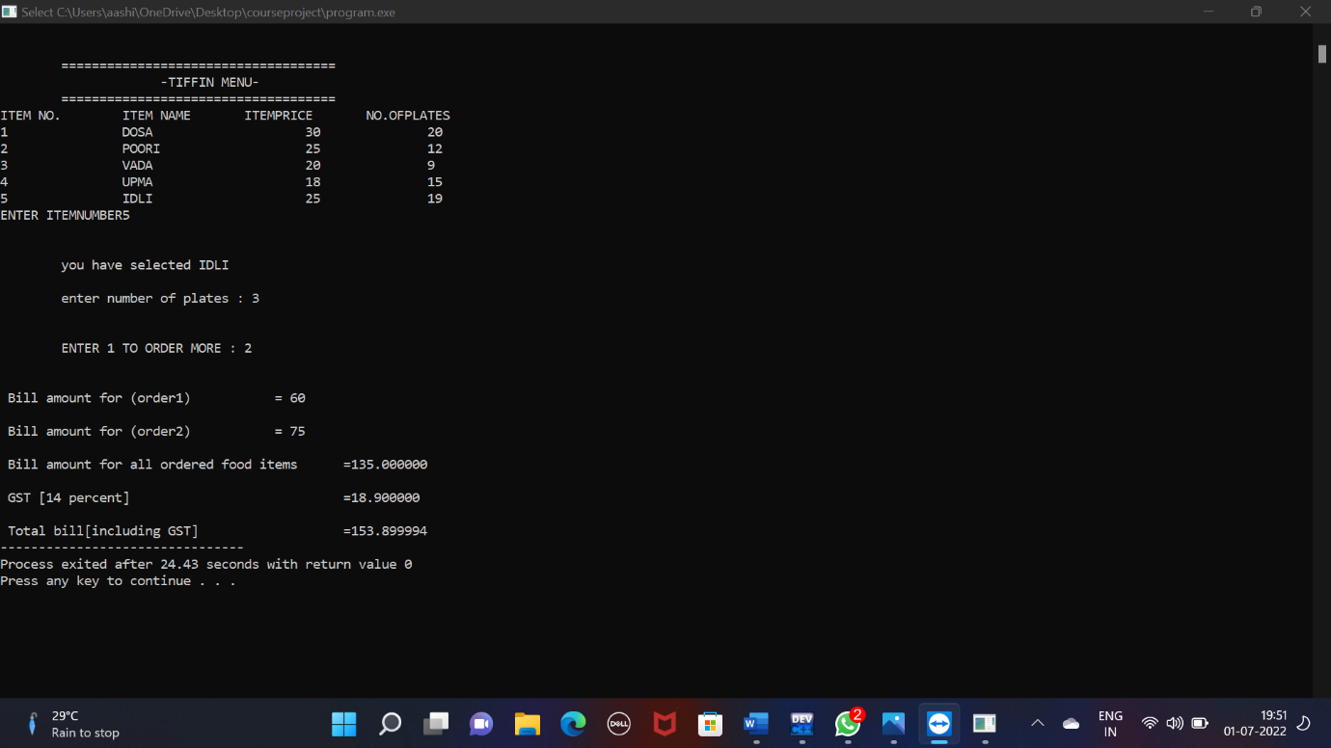

OUTPUTS OF FILES

